1. **Perform Perspective Transformation on the image.**

**Aim:**

To perform perspective transformation on the image.

**Code:**

import cv2

import numpy as np

img = cv2.imread("C:\\Users\\prith\\Documents\\CV\\cvimage.jpg")

rows, cols, ch = img.shape

pts1 = np.float32([[56, 65], [368, 52], [28, 387], [389, 390]])

pts2 = np.float32([[100, 50], [300, 0], [0, 300], [300, 300]])

M = cv2.getPerspectiveTransform(pts1, pts2)

dst = cv2.warpPerspective(img, M, (cols, rows))

cv2.imshow('Perspective Transformation', dst)

cv2.waitKey(0)

cv2.destroyAllWindows()

**Input:**

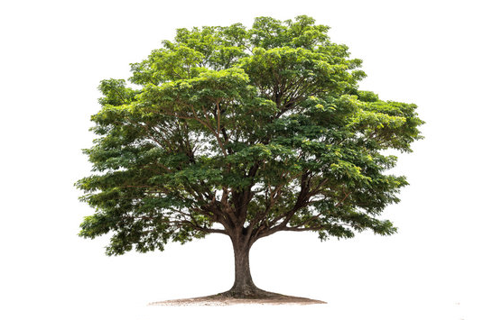

**Output:**

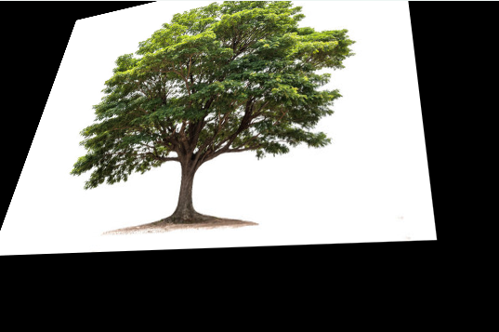

**Result:**

The python code to perform perspective transformation on an input image has been executed successfully.